Seventh International Conference on  Computational Fluid Dynamics (ICCFD7),  Big Island, Hawaii, July 9-13, 2012 | ICCFD7-xxxx

Paper Template of 7th International Conference on Computational Fluid Dynamics in Big Island, Hawai’i 2012

D. Reynolds*, C. Kelly* and F. Reynolds*,**
Corresponding author: d.reynolds@paddyspub.xyz

* Paddy’s Pub, USA
** Sunny Real Estate, USA.

Abstract: The body of your abstract belongs here. ICCFD is the outcome of the merger of two important CFD conferences: the International Conference on Numerical Methods in Fluid Dynamics, ICNMFD (since 1969) and International Symposium on Computational Fluid Dynamics, ISCFD (since 1985). The first ICCFD conference was held in 2000 in Kyoto, the second in 2002 in Sydney, the third in 2004 in Toronto, the fourth in 2006 in Ghent, the fifth in 2008 in Seoul and the sixth in 2010 in St Petersburg. The seventh conference, ICCFD7 will be held on the Big Island of Hawai’i in July 2012.

Keywords: Numerical Algorithms, Computational Fluid Dynamics, Turbulence Modeling, Aeroacoustics.

1 Introduction

This is the main part of the paper. Its length should be no longer than 25 pages, including key figures and references. It can be divided in as many sections as you decide. The paper must be prepared using this template and compiled using standard LATEX, generating a PDF file that will be finally uploaded. If another kind of word processor is utilized, please adhere to the formatting provided in the PDF template.

2 Problem Statement

This document allows you to easily include references [1, 2], equations, figures (see Figure 1) or any- thing else you desire into a clean and compact environment of LATEX. For example if you’d like to impress a date you can write the unsteady heat equation as
where x,y,z are the space dimensions and α is a parameter. If you felt inclined you could define V as
for a non-exact solution. Computational fluid dynamics can be used to discretize the equations, apply boundary conditions and simulation the unsteady nature of the flow. An innovative method to simulate the heat equation could even be submitted to ICCFD7.
The scope of ICCFD7 is devoted to all innovative aspects of CFD, basic and applied. Subjects of interest include but are not limited to

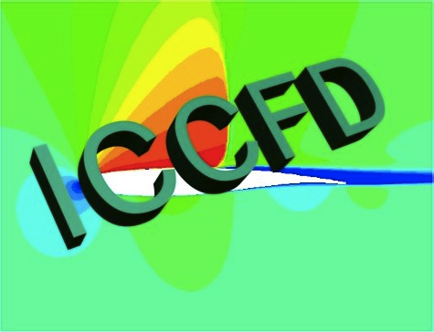

Figure 1: This is the logo of ICCFD.

- Innovative algorithm development for flow simulations: higher-order methods, iterative methods, parallel algorithms, mesh adaptation, grid generation, meshless methods, immersed boundary methods and level-set methods.

- Advances in modeling of flow physics in the area of: steady and unsteady flows, compressible and incompressible flows, flows in porous media, hypersonic and reacting flows, turbulence (transition, DNS/LES, etc.), multi-phase flows, boundary layer stability and vortex dynamics.

- Advanced multidisciplinary applications using the above mentioned technologies: aeroacoustics, flow control, biomedical fluid mechanics, large scale applications, verification and validation methods, and turbomachinery.

2.1 Subsection Title Example
2.1.1 Sub-subsection Title Example

3 Conclusion and Future Work

ICCFD7 will be held on the Big Island of Hawai’i at the beautiful Mauna Lani Bay Hotel. Situated amidst mountains and the sea on the sunny Kohala Coast on the tropical island of Hawai’i, the venue offers a gorgeous backdrop. We wholeheartedly invite you to attend and make reservations while reduced conference rates are available. Aloha. Sdfsldkf
Sdlk

References

- J. Doe. Important book title: A complete work. ACME. 2012.
- J. J. Doe and B. Schmit. Novel approach to innovation and synergy. Int. J. Sci. Tech., 54:695-706, 2012.

